**schools to watch – Indiana Schools To Watch**

**model school – visitor’s guide**

**2018-2019 School Statistics**

Community: Rural

Enrollment: 467

Grade Levels: 6-8

School Schedule: traditional

Student Demographics

* 0.41% Native American
* 95.13% White
* 2.4% African American
* 1.23% Multi-racial
* 0.83% Asian
* 20.17% Free/Reduced Lunch

*10 time 4-Star School

2011, 2014, 2017 National and State Schools to Watch

-Staff Attedance 97.5% Student Attendance 97.3%

|  |  |  |  |
| --- | --- | --- | --- |
| ISTEP+Scores | 2016 | 2017 | 2018 |
| Math | 73.9 | 76.0 | 76.9 |
| English/LA | 81.6 | 82.7 | 77.8 |
| Science | 88.9 | 90.5 | 82.4 |
| Soc Studies | 88.3 | 82.7 | 80.7 |
| Attendance | 97.4% | 97.5 | 97.3 |
|  |  |  |  |

**Tri-West Middle School**

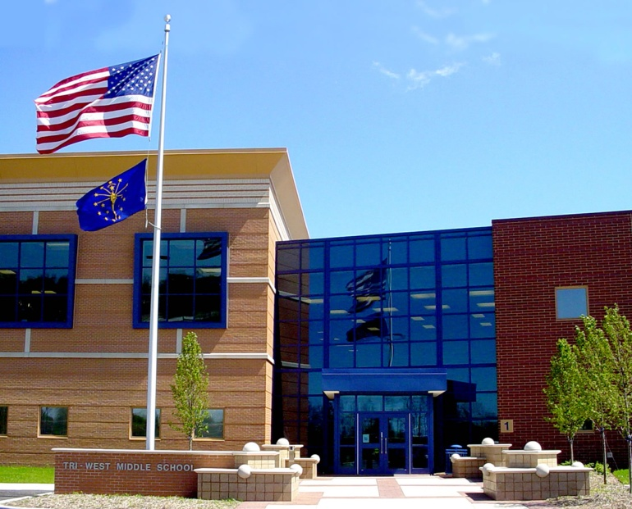

**Designated in 2011**

**Designated in 2011 & Re-Designated in 2014 and 2017**

**Tri-West Middle School● North West Hendricks**

**School Corporation● Hendricks County**

**Ryan Nickoli, Principal**

[**nickolir@hendricks.k12.in.us**](mailto:nickolir@hendricks.k12.in.us)

**555 W U.S. HWY 136, Lizton, IN 46149**

**Tel (317) 994-4200, Fax (317) 994-4230**

**School Characteristics and Replicable Practices**

**Academic Excellence**

• **Tri-West Middle School has earned a Four Star rating by the Indiana Department of Education ten times through the years**

**\*Project based Learning has become an integrated part of the curriculum across grade levels. There are multiple opportunities for students to collaborate and work together. A new Maker’s Space Lab opened for the 2017-2018 school year. We are also adding a STEM teacher and lab for the 2018-2019 school year. We currently offer a STEM 7 and STEM 8 course which all students take for a semester.**

**\*A “Success” period has been added to the end of the day. All students in 8th grade not in Spanish or Intro to Engineering are placed in either remediation or enrichment during this time frame.**

**\*There has been a strong focus and implementation of the Four Literacy Shifts across grade and content areas. Students are regularly introduced to strong academic vocabulary, close reading, use of textual evidence, and argumentative writing.**

**\*A major re-focus has taken place during the 2018-2019 school year in the area of UbD. We have targeted performance task for students to complete which focuses on transfer of learning for students. All teachers will be required to have four performance task to begin the 2019-2020 school year. The idea is for students to take what they have learned and transfer that learning with them.**

• **Marzano’s “Six Steps to Teaching Academic Vocabulary” is a best practice to support our school wide vocabulary goal. The study of vocabulary is systematically implemented across grade levels, and grade level lists are built upon each school year until each student possesses a large vocabulary in each of the content areas. Every classroom has a listed of ISTEP vocabulary and content area vocabulary for students to view and comprehend.**

• **A data wall is updated yearly charting student progress on NWEA, ISTEP(ILEARN), each teacher’s subject area vocabulary, problem solving testing, and ability to use textual evidence.**

*\**

*\****Student data binders detail student test scores on ISTEP, NWEA, subject area vocabulary scores, problem solving, and use of textual evidence and are evolving to student led conferences. Student led conferences have been implemented at all grade levels for the past four years. In 2017-2018 we did Student Led conferences digitally for the first time. Participation fell slightly since it was done at home, but did bounce back for the 2019-2020 school year. We believe our 1:1 chrome books helped us reach the 100% goal.**

• **Tri-West Middle School offers nine classes to our 8th grade students for high school credit. They include, Algebra, pre-algebra, English 9, Biology, Current Events, Spanish I, Intro to Engineering, PE 9 and 2D art. Every student has a chance to leave with at least one high school credit under their belt.**

• **Teachers utilize the Understanding by Design method of unit planning to assure that each lesson is planned with the desired standards based learning outcome in mind (focus on performance task and transfer goals)**

• **Teachers are required to incorporate differentiated instruction lessons each nine weeks. Differentiated plans/units are incorporated into the teacher data binders. The middle school has formed a DI share board for staff members, using Carolyn Coil’s strategies as a guiding force.**

• **Each staff member chooses an underachieving student to mentor throughout the school year.**

• **Numerous professional development opportunities are provided to teachers to help enhance their knowledge of state standards and curriculum. While professional development opportunities are available outside the school, we reinforce and promote a train the trainer mentality.**

**\*Technology is integrated throughout the school. Each classroom does have a promethean board. We also utilize School as our learning management system. In addition, students will all receive a chrome book for the 2018-2019 school year.**

**\*All teachers have implemented quarterly assessments, using a pre and post-test as data providers. Following each quarterly assessment, the building principal meets with each teacher to discuss data results and other curricular issues. These TAP (teacher and principal) talks focus on the curriculum, instruction, data, and best practice. Teachers are in the process of creating assessment plans and performance tasks as well.**

* **Special education teachers co-teach with math, reading, language arts, science, and social studies teachers.**

• **Teachers volunteer their time before and after school to work with students that need extra assistance in all subject areas.**

• **Student attendance rate was 97.3 for the 2017-2018 school year and has been over 97% for at least 6 straight years. We are on target to reach this goal again for the 2018-2019 school year.**

• **Strong evidence that multiple assessment tools are used by all teaching staff.**

**Developmental Responsiveness**

• **Each student meets daily during PRIDE TIME with a faculty member. PRIDE TIME is an 18 minute advisory period where students experience team work, foster social skills, and develop responsibility skills. The staff strongly believes in building positive relationships with our students, hence the PRIDE acronym of Positive Relationships in Developing Excellence.**

**\*Starting the 2018-2019 school year the middle school did transition back to an 8:25 start time which we believe is more developmentally appropriate for adolescent kids. The district also saw the need to do dual routing for our buses, which keeps elementary and secondary schools off the bus with each other.**

**\*Tri-west Middle School has implemented anti-bullying programs across grade levels that are done by our guidance program.**

**\*The last two years we have created character lessons within the PRIDE group. We typically do 1-2 lessons a month on various topics/themes.**

**\*There are numerous opportunities for students to get involved with service projects via students council and our newly formed “Builders Club and art club). An art club is new within the last couple of years and robotics is new this year.**

• **Student achievement levels are met by multiple curricular offerings which include 9 courses offered for high school credit at the 8th grade level.**

• **Strong evidence supports the fact students feel safe and are content at school. Surveys are routinely done for students, staff, and parents. These show that students do feel safe at school, but also clearly shows that bullying is the number one concern by MS kids.**

• **Teachers are organized into grade level teams which allows for collaboration for interdisciplinary projects.**

• **Team leaders contact parents to set up parent/teacher conferences.**

• **Convocations are held to enrich our students’ diversity.**

• **Students have a full range of co-curricular activities**

**\*A mentor program has been established that target students that might be having academic, behavior, social, and/or any other issues related to middle school. Adults in the building currently support over three dozen students in this program.**

**\*Study buddies/peer mentoring is used for students struggling with organizational and academic needs.**

**\*Tri-West Middle School strives to find ways to make the community part of the school experience. In addition to the multiple efforts listed below to help out community partners**

**\*Tri-West Middle School participates in Read Across America Week which allows several community members to volunteer their time to read to and talk with our students about the importance of reading.**

**Social Equity**

• **Tri-West Middle staff continuously reviews the curriculum, instructional methods, assessments, and scheduling in order to best meet the needs of all students.**

• **Special education teachers and instructional assistants are part of the general education classes to provide inclusion support for all students.**

**\*Parents/guardians are able to come in to work with teachers on Meet the Teacher Night, Parent Teacher Conference Night, Student-Led Conference night, and any other time they are able to set up meetings with individual teachers.**

• **Students are active in the community through community clothing and food drives, Riley Children’s Hospital, St. Jude’s Children’s Research Hospital, Hat & Glove drives, shoe drives, and canned food drives**

• **Renaissance is the driving force behind all incentive and recognition programs. The four R’s of Renaissance are respect, recognition, reward, and reinforce. Our High 5 Luncheons, Student of the Month, Honor Roll Breakfast of Champions, Perfect Attendance, and Random Acts of Kindness are some of our incentive programs.**

**\*100% of the student body has been recognized for 12 straight years. This includes 100% percent already during the 2018-19 school year. It is always the goal of our school to have such recognition for our students.**

**\*Peer facilitators are used in our Life Skills room. This gives are students a unique opportunity to work with some of our special education students.**

• **Our parent group, PRIDE PARENT GROUP, takes an active role as it plans and supports after school activities, runs the school bookstore, and offers support to the staff throughout the school year.**

• **Tri-West Middle School keeps parents/community members informed through our school website, newsletters, our digital message board, parent conferences, student led conferences, committees, phone calls (school messenger), and our web programs – Schoology, harmony, google docs**

**\*It is our belief that every student is unique and each of the needs to be encouraged, guided, and motivated to develop to his/her full potential. We offer a wide variety of inclusion classes, where resource teachers assist students on a daily basis. In addition, we have a high ability program called the Learner Enrichment and Academic Program (LEAP) to help meet the learning styles of all students.**

**\*Students are offered a “Success” period in 6th and 8th grade which is utilized for getting additional help from teachers and receiving intervention and remediation in classes. This is also a time for students to receive enrichment opportunities if they are not in remediation.**

**Organizational Support**

**\*At Tri-West Middle School we have clear and evident Mission and Vision statements. This did change this year for the entire district. Heading into the 2018-2019 school year our Mission will be, “Preparing today’s learners to become tomorrow’s leaders”. Our vision will read, “**With an emphasis on personal relationships and individualized learning, our PreK-12 learners will develop into the most sought after candidates for colleges/universities, the workforce, the military, or apprenticeships.

**\*Core values are posted, respected, and followed through with. In addition, the Five R’s of Renaissance are a constant them. (Respect, Reinforce, Recognition, reward, and results)**

**\*The PL 221 plan is reviewed, edited, and shared in order to reach school wide goals.**

**\*A professional library with multiple journals, subscriptions, and other literature is available for staff to use as needed.**

**\*STW goals and vision are part of the climate at Tri-West Middle School.**

**\*Bring Your Own Device (BYOD) just finished on year four of implementation. All students and staff will receive chrome books. As part of this, “Schoology” has been adopted as our new Learning Management System for staff and students. A 1:1 chrome book initiative started for the 2018-2019 year.**

• **The school improvement process is embedded at Tri-West Middle School with strong leadership from the district leadership, building level administration, and the teacher teams.**

• **Core values are shared throughout the school building and corporation to provide a guide to future planning.**

**\*The administration is involved with activities within the classrooms and provides support to grade level teams in achieving long and short term goals.**

• **Students and staff are encouraged and supported in educational endeavors. Through professional articles, periodicals, books, and workshops teachers work to develop best practice approaches and collaborate regularly to continuously assess and improve the educational environment.**

• **High expectations are set for all students and staff members.**

• **Articulation awareness exists between the elementary schools and the high school.**

• **Staff is actively involved in the Indiana Middle Level Education Association, National Middle School Association, Association for Supervision and Curriculum Development, National Council of Teachers of Mathematics, Learning and Project Lead the Way for engineering integration.**

**\*The middle school shares staff with the high school to offer courses in Engineering and Spanish.**

• **Communication and accountability is fostered by monthly administrative, team, and staff meetings**

**\*A district Wide Plan on a Page helps guide our decision making process, while ensuring all schools stay on the same page and have a shared vision for our district.**